I don’t even know if this is what was required of me. I’ve been overworked for weeks, and I just want it all to end. One way or another.

Customer Side:

* Navigation Bar
* Store Page
* Login Page
* Registration Page
* Cart Page
* Account Page
* Account Information Page
* Account Orders Page

Client Side:

* MySQL Server Inferface
* MySQL Interface
* PHP Interface
* NginX Interface

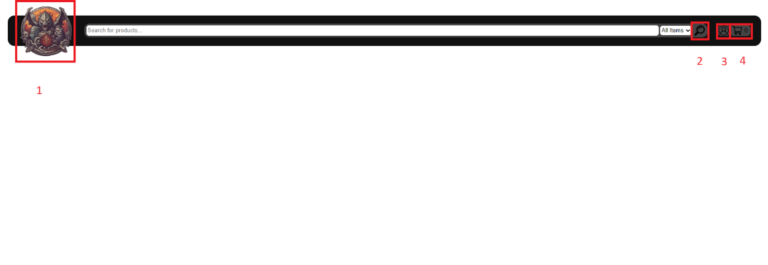Navigation Bar (present on every page to comply with 3-click policy):

1. Takes you to the landing page.
2. Takes you to store page.
3. Used for account management:
   1. If you’re not logged in: Takes you to login page
   2. If you’re logged in: Takes you to account page
4. Takes you to the cart page.

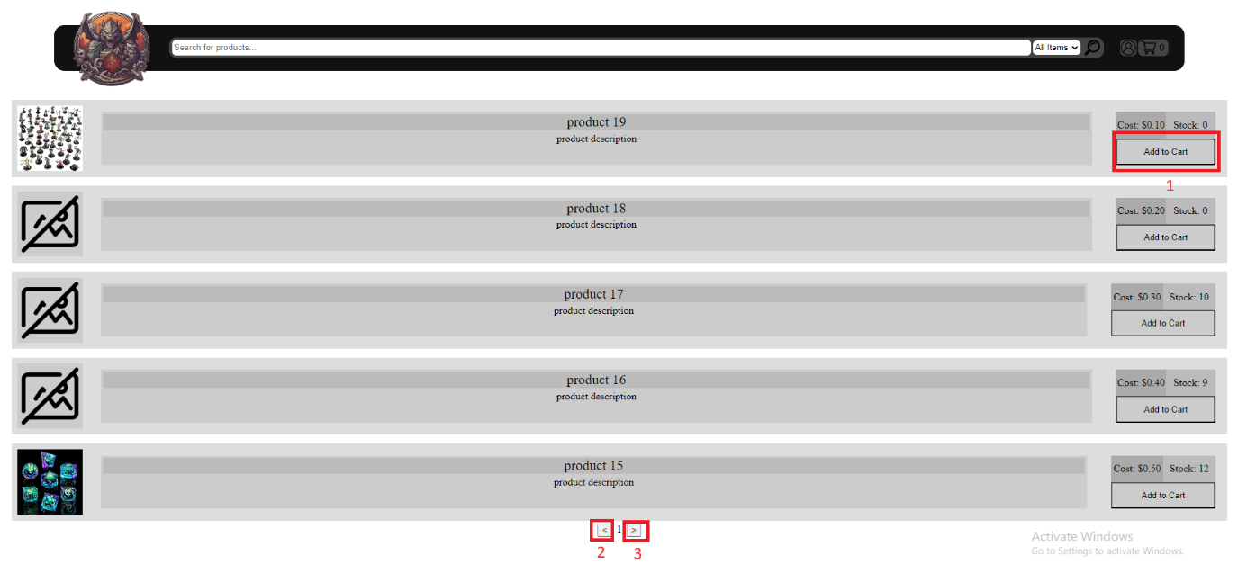Store Page:

1. Adds the item to your cart
2. Navigate to previous store page.
3. Navigate to next store page.

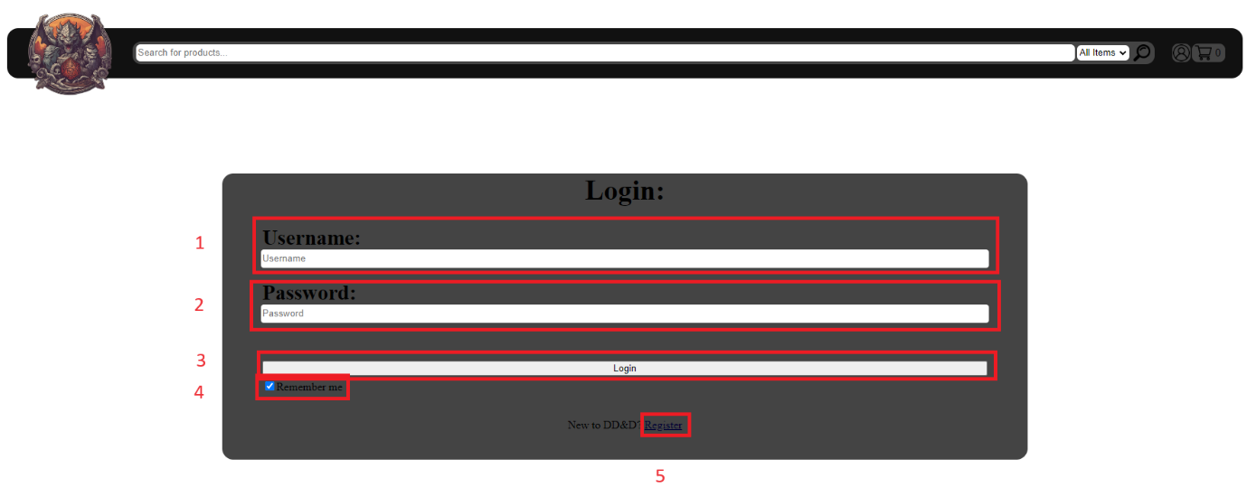Login Page:

1. Username Input.
2. Password Input.
3. Login Button
4. Select whether you want to be forgotten.
5. Navigate to registration page.

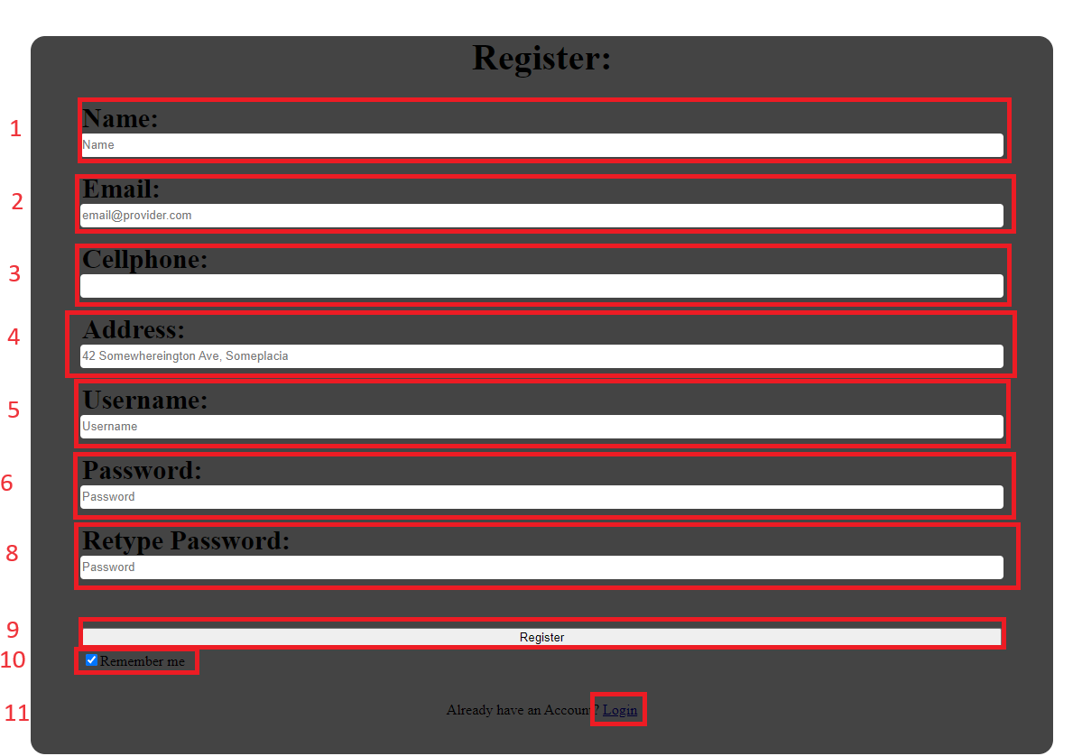Registration Page:

1. Name input
2. Email input
3. Cellphone Number input
4. Address input
5. Username input
6. Password input
7. Password reinput
8. Registration button
9. Choose if you want to be forgotten
10. Navigate to Login page.

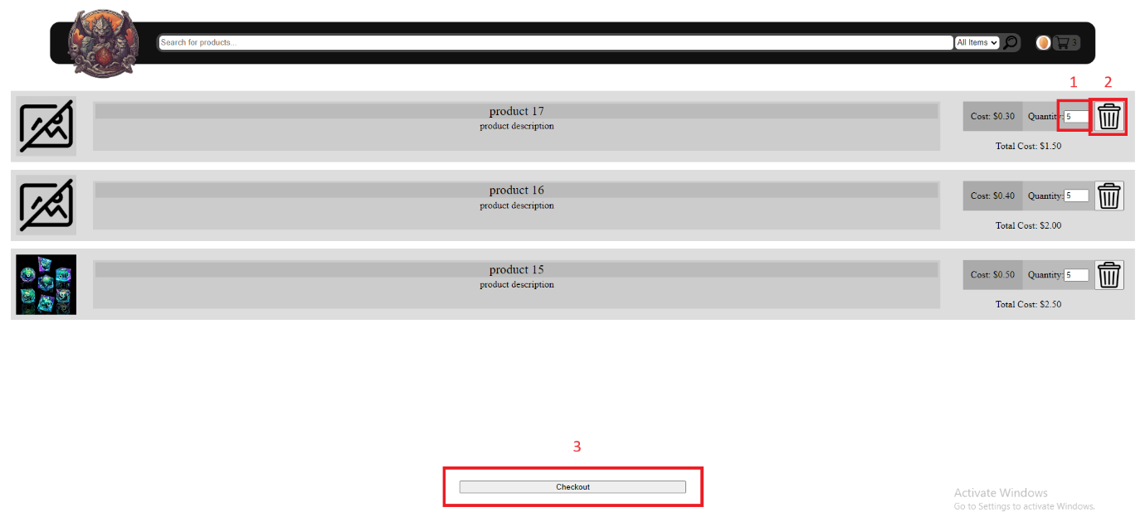Cart Page:

1. Modify number of that item in the cart
2. Remove item from cart
3. Checkout (which will modify how much of the item is in stock)

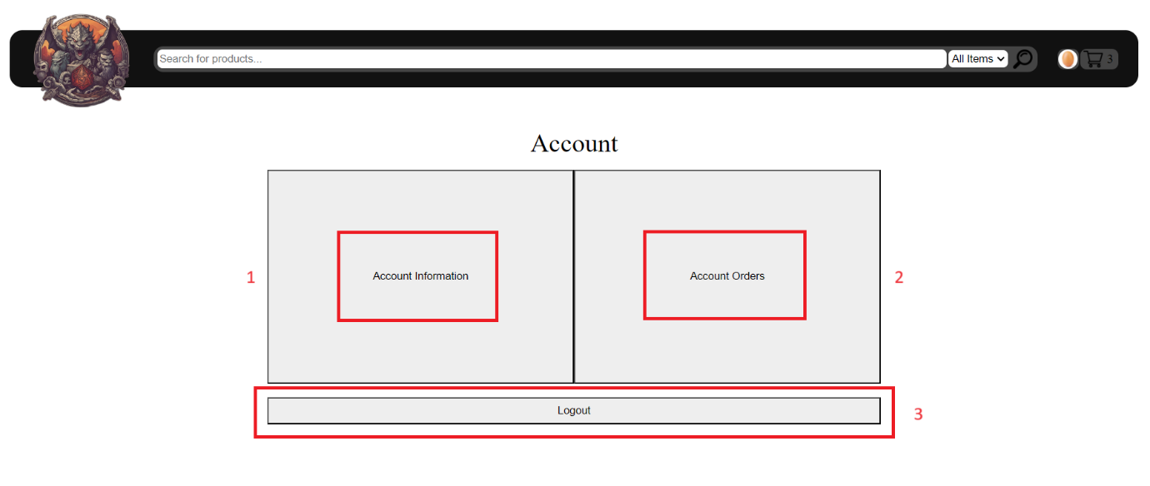Account:

1. Navigate to Account Information
2. Navigate to Account Orders
3. Log out of Account

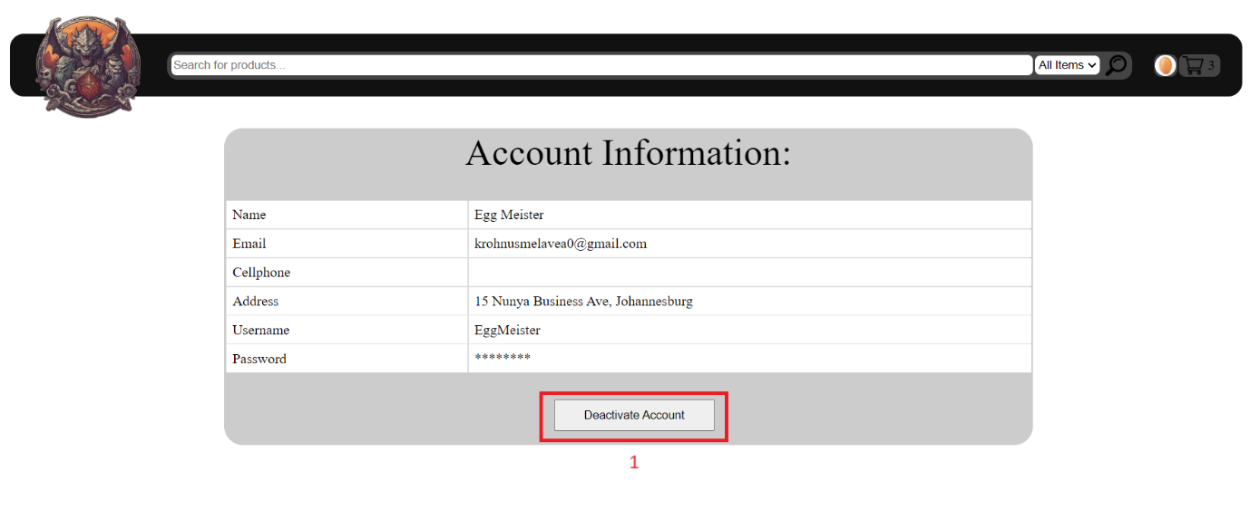Account Information:

1. Deactivate account and remove all personal information from database.

Account Orders:

MySQL Server Interface:

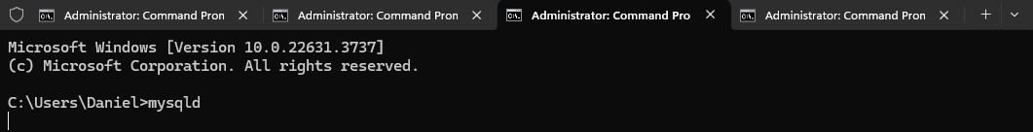

MySQL Interface:

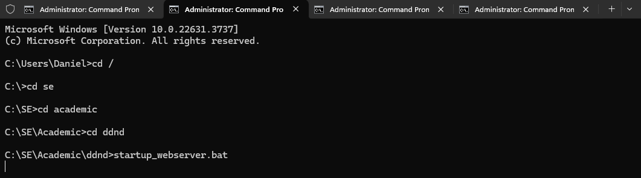

PHP Inteface:

NginX Interface:

